STP Test Case # ST-2
Requirement tested: FR-8.1
Determination: UNSUCCESSFUL
Setup:
1. Open the Chrome browser on Windows OS
2. Navigate to front-facing Moxie server
(http://moxie.cs.oswego.edu:7000/)
3. Execute test
Execution:
1. Load the moxie server
2. Inspect if the load event that was triggered (not shown)
Expected Result:
1. A log entry is created each time the home page is loaded. 2. The log has information such as load event triggered, timestamp of the event, and event status
Screenshot:
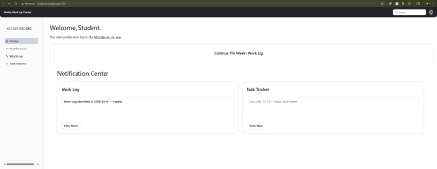
STP Test Case # ST-2
Requirement tested: FR-8.2
Determination: UNSUCCESSFUL?
Setup:
1. Open Safari browser on MacOS.
2. Navigate to the front-facing Moxie server
(http://moxie.cs.oswego.edu:7000/)
3. Log in as a student user.
4. Generate a notification by adding a task or submitting a report. Execution:
1. Load the moxie server
2. Turn the wifi off on my laptop
3. Refreshed the page
Expected Result:
1. If homepage data fails, a log should be generated.
2. The log has information such as event type triggered, failure reason, timestamp of the event, and event status
Screenshot:
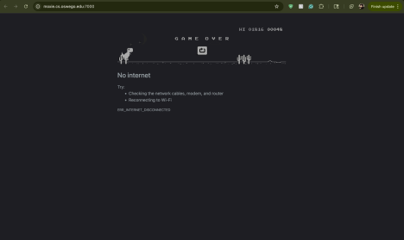
Bug/Defect # Defect
Severity: Low
STP Test Case # ST-2
Build/Release #?
Steps during test:
1. Open the Chrome browser on Windows OS
2. Navigate to the Homepage on the Moxie website
3. Inspected for a load event to be triggered
Description:
During FR-8.1/ST-2, when I opened the home page and refreshed it a few times, I didn’t notice any load event triggered or anything logging.
Potential Cause (if known):
Not too sure.
Screenshot shown above
Bug/Defect # Defect
Severity: Low
STP Test Case # ST-2
Build/Release #?
Steps during test:
1. Open Chrome browser on MacOS
2. Loaded the home page
3. Turned off the wifi connection on my laptop
4. Refreshed
5. Turned the Wi-Fi back on
6. Inspected home page
Description:
During FR-8.2/ST-2, I turned off the Wi-Fi and saw the standard Chrome message that I can't access the website without an internet connection. When I turned it back on, it didn't log anything of an error or disconnection
Potential Cause (if known):
Don’t know
Screenshot provided above

